

EDN.GC.MTR(E-22)2025-2026-
Office of the Principal,
Govt. College Matour
Distt. Kangra (H.P) Dated : March 2026

To

The Director of Higher Education
Himachal Pradesh
Shimla -01

Subject: - Information regarding establishment of Road Safety Clubs.

Sir,

Kind reference to your office letter No. EDN-HE(3)F(10)42/2025-Road Safety dated 29-10-2025. In this context the Information regarding establishment of Road Safety Clubs is being sent to your good office with prescribe Proforma for further necessary action please.

Ends No :- Even Dated : Mar 2026

Encls:
1. Utilization Certificate (“ANNEXURE-A”)
2. Abstract of Expenditure (“ANNEXURE-B”)

-2-
“ANNEXURE-A”
(Session 2025-2026)
FORM OF UTILIZATION CERTIFICATE
(for funds released out of the Road Safety Fund of the Transport Department)

Details of the funds released under the Road Safety Fund,
in r/o Govt. College Matour (Kangra)

Sr. No | Purpose | Released Letter No (If any) | Released date  (if any) | Released amount (in rupees)
1. | Establishment of Road Safety Club in Educational institution & Generating awareness about road safety and traffic signals through various competitions like poster making painting, Slogan writing, easy writing, Student road safety awareness rally and declamation etc. | EDN-HE(3)F(10)42/2025 dated 29-10-2025 | 27-10-2025 | 10000/-
Total fund Released |  |  |  | 10000/-
 | Total fund utilized |  |  | 10000/-
 | Balance of unutilized fund |  |  | -NIL-

1. Certified that the aforementioned figures are true and correct as per the available office record.
2. Certified that proper record has been/is being maintained for entire expenditure incurred out of the funds released above, and the same shall be placed for scrutiny/audit, as and when so required by the HPDT/AGHP/ or any other authorized party.
3. Certified that the amount has been utilized for the purpose it was sanctioned as prescribed in the guidelines/SOP.
4. Certified that all codal formalities have been duly fulfilled and the undermentioned checks have been exercised to ensure that the money is actually utilized for the purpose for which it was sanctioned.
Kind of Checks Exercised:-
(a) Cashbook, vouchers and other related records are being maintained for each and every transaction.
(b) All expenditure is incurred strictly in compliance to the Himachal Pradesh Financial Rules 2009, the Himachal Pradesh Treasury Rules 2017, and other related rules/regulations circulated by the Government from time to time.

Dated : 19-03-2026 (Signature with official seal) Name & Designation ____________________

-3-
“ANNEXURE-B”
Session (2025-2026)
FORM OF ABSTRACT OF EXPENDITURE
(for funds released out of the Road Safety Fund of the Transport Department)
Details of the expenditure incurred out of the funds released under the Road safety fund as per “ANNEXURE-A” in respect of this office:
S. No | Name of Activity | Place of Activity | Date/Period of Activity | Expenditure Incurred
1. | Pledge | GDC Matour | 03-10-2025 | --
2. | Awareness Campaign | GDC Matour and Villages nearby | 04-11-2025 | --
3. | Awareness lecture DSP Kangra | GDC Matour | 11-11-2025 | 2493
4. | Stationary | -- | -- | 750
5. | Quiz Completion | GDC Matour | 15-11-2025 | 1150
6. | Prize Distribution (Road Safety) | GDC Matour | 03-03-2025 | 1800
7. | Prize Distribution function  Annual Function 2025-2026 (SAMARITAN) | GDC Matour | 10-03-2026 | 1959
8. | Road safety Flex Board | -- | -- | 1848
Total Expenditure |  |  |  | 10,000/-

Name/ Signature (Nodal Officer Road Safety)
GDC Matour (Kangra)

Dated : 19-03-2026 (Signature with official seal) Name & Designation head of the Institution ___________________

-4-

Pledge on 03-10-2025
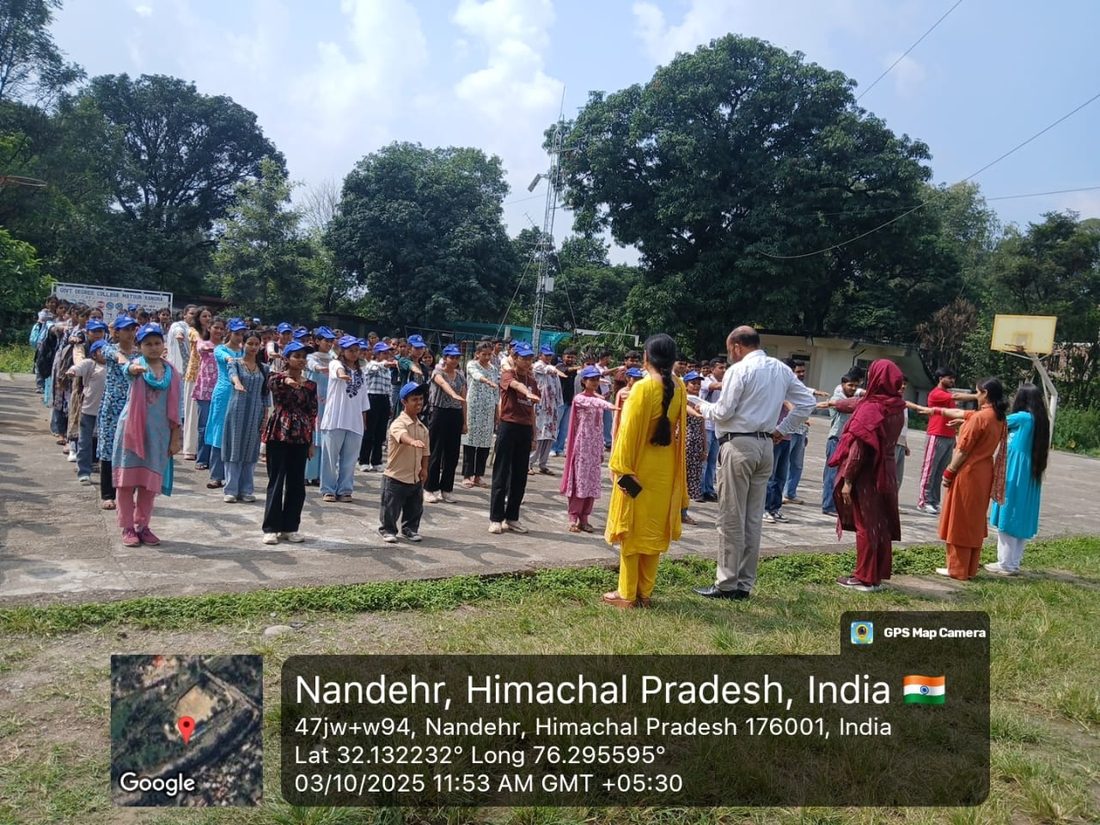

Awareness Rally 04-11-2025
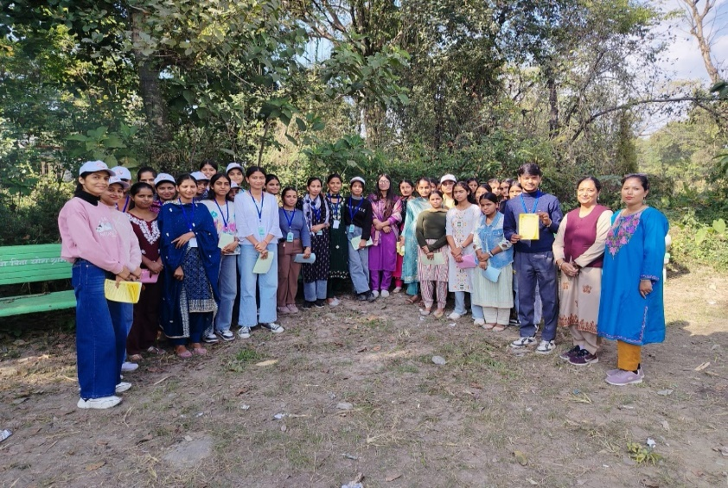

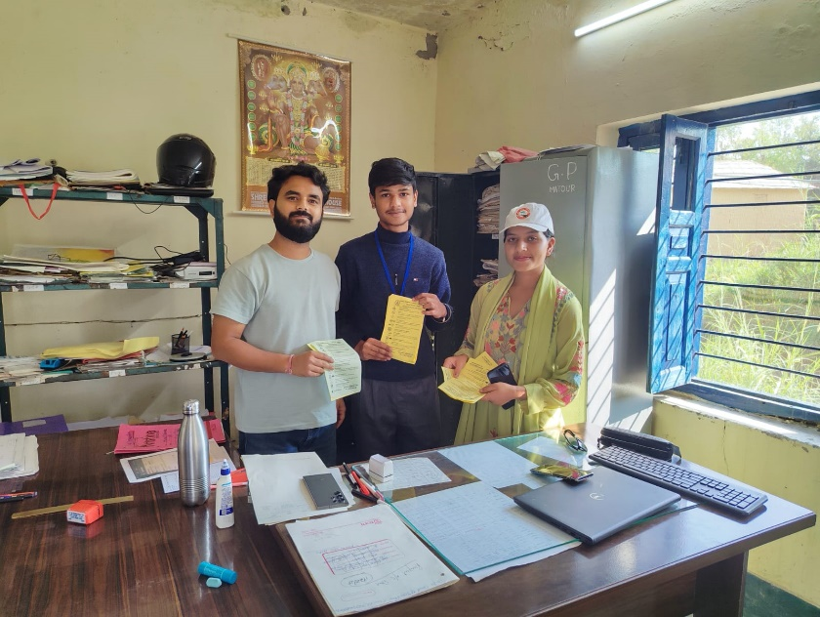
-5-
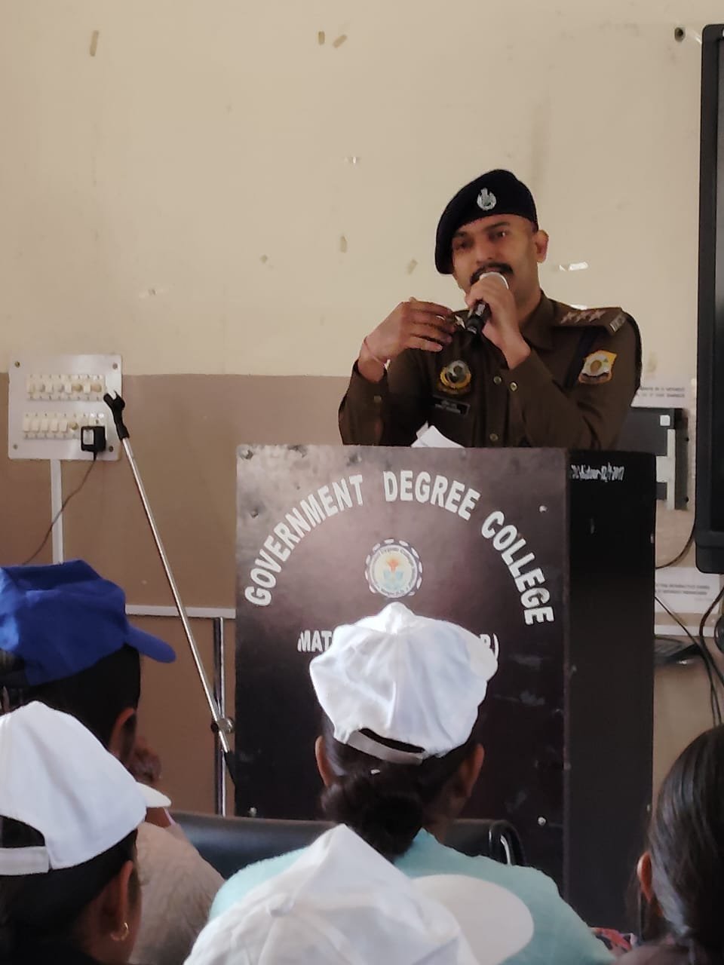
Awareness Lecture 11-11-2025

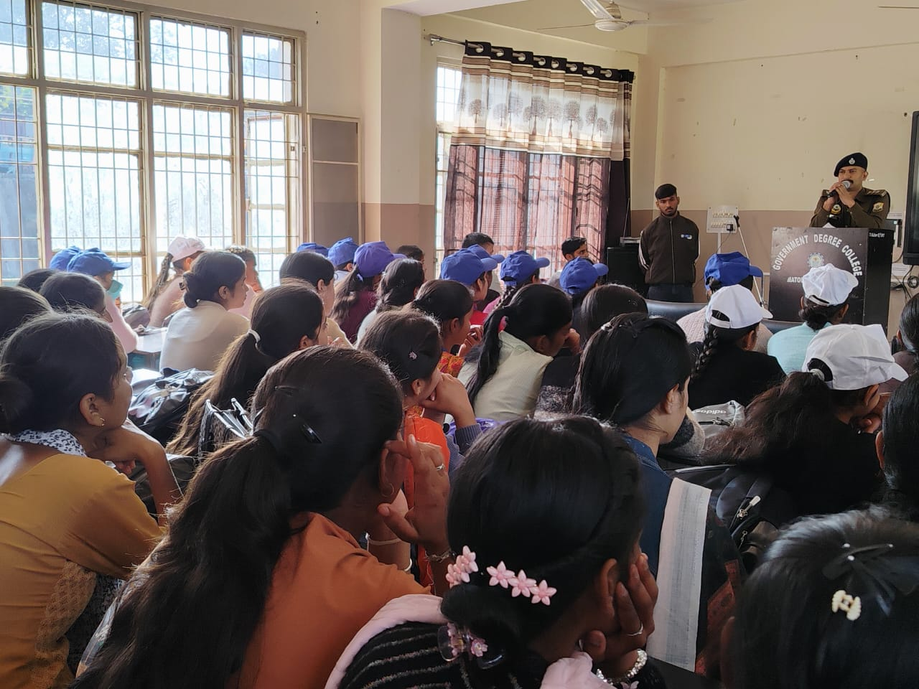

-6-

Quiz Competition 15-11-2025
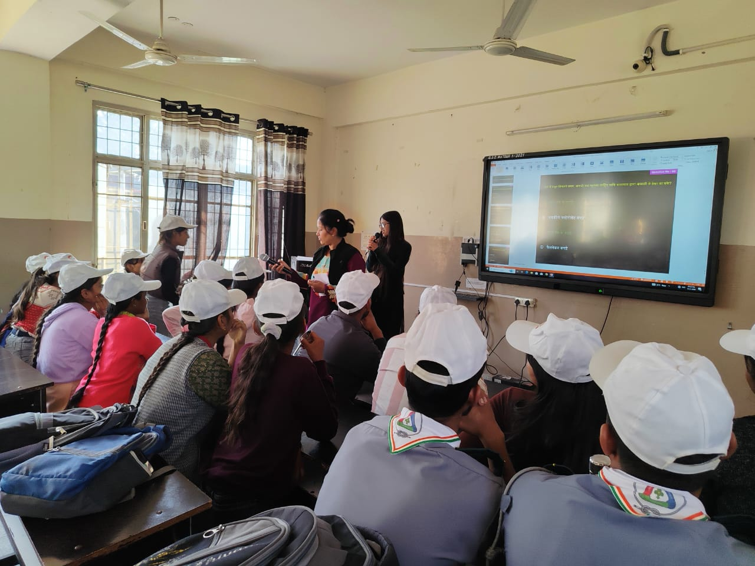

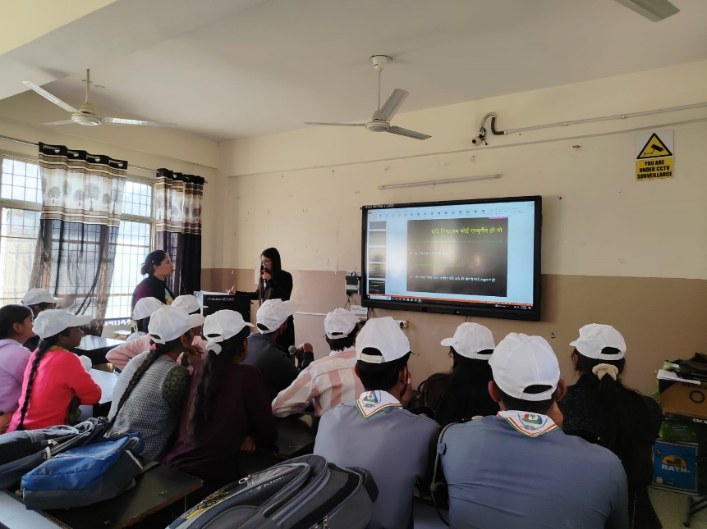

-7-
Road Safety Club Prize Distribution: 03-03-2026
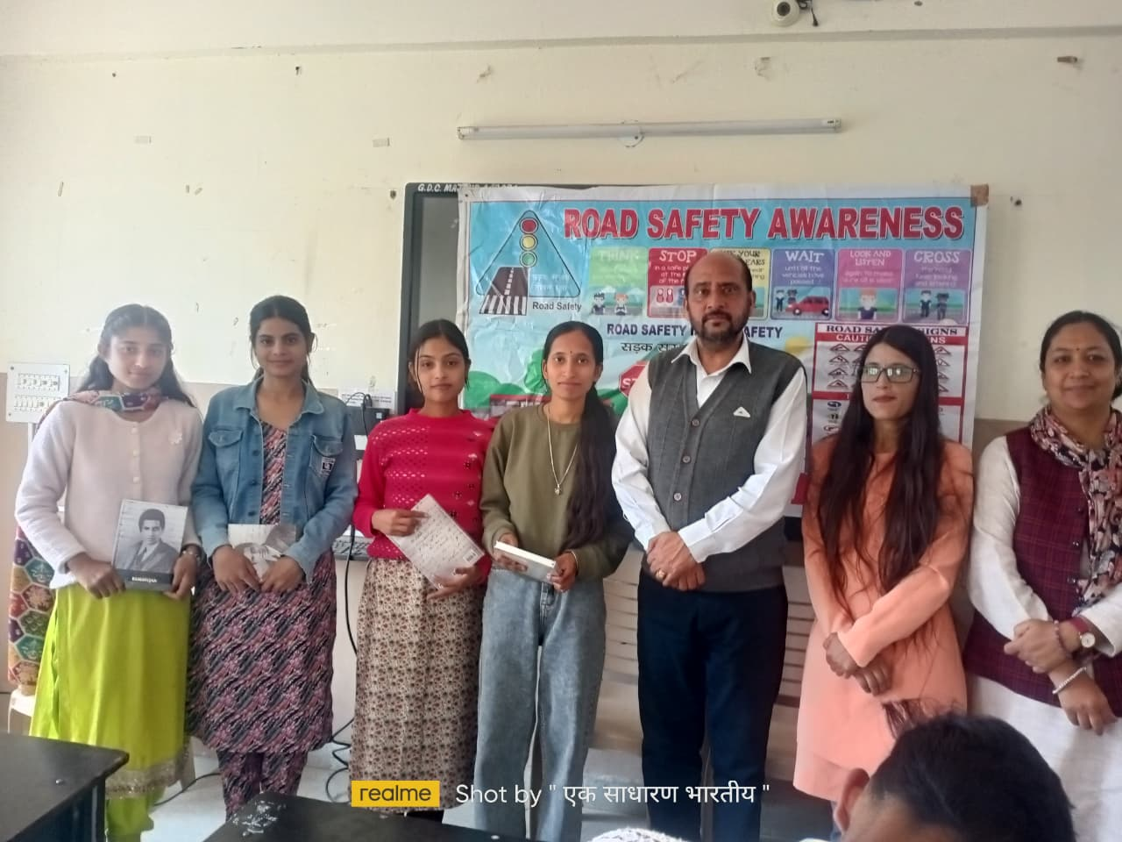
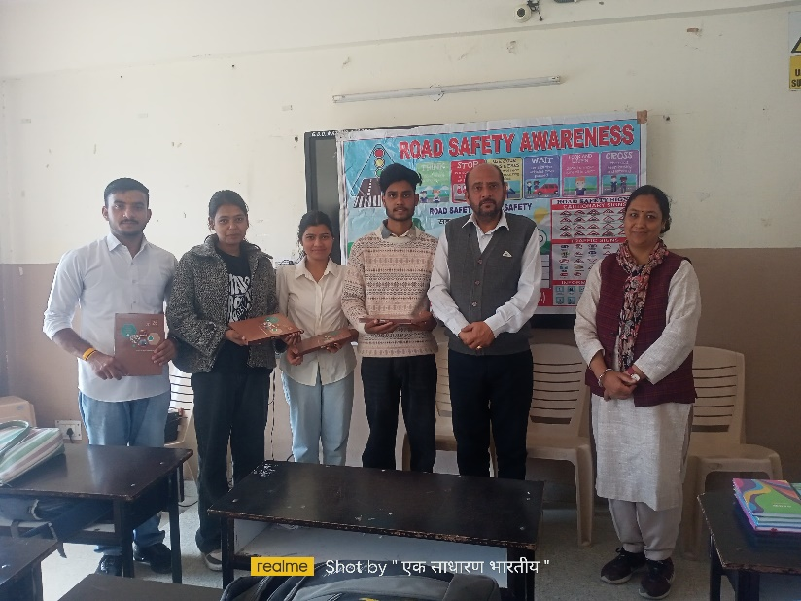

-8-
Annual Prize Distribution 2025-2026 : 10-03-2026
(SAMARITAN)
